EXPERIMENT 4
ROLL NO: 240701533 NAME: SRITHIKA.S
Create a prototype with familiar and unfamiliar navigation elements. Evaluate ease of use with different user groups using proto.io.
SCREEN :01
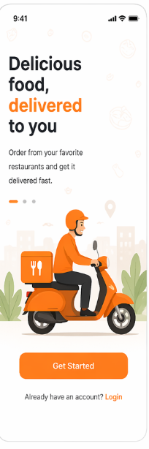
Familiar Elements:
- “Get Started” Button
  - Common CTA used in almost all apps
  - Users know it proceeds to the next screen
- Login Link
  - “Already have an account? Login” is standard
  - Helps returning users
- Illustration + Heading
  - Common onboarding design pattern
Unfamiliar Elements:
- Swipe to Continue
  - Instead of tapping, users swipe → may not be obvious
- Animated Delivery Icon
  - Might distract or confuse some users

SCREEN:02
Familiar Elements:
- Search Bar
  - Used to find food/restaurants quickly
- Hamburger Menu (☰)
  - Opens side navigation
- Bottom Navigation Bar
  - Home, Orders, Favorites, Profile
- Category Icons (Pizza, Burger, etc.)
  - Easy visual recognition
Unfamiliar Elements:
- Horizontal Swipe Categories
  - Users may not realize it’s scrollable
- Dynamic Offer Banner (Auto-slide)
  - Moves automatically → can confuse some users

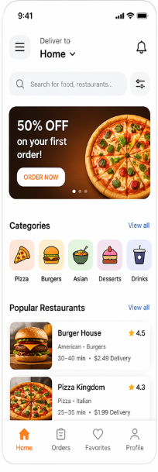
SCREEN:03
Familiar Elements:
- Food Cards (Image + Price + Add Button)
  - Standard layout in food apps
- Rating ( 4.5)
  - Widely understood system
- “Add (+)” Button
  - Used to add items to cart
- Back Arrow (←)
  - Navigates to previous screen
Unfamiliar Elements:
- Swipe to Add to Cart
  - Instead of tapping “+”
  - Not obvious for new users
- Hidden Menu Filters (Gesture-based)
  - Users may not discover easily

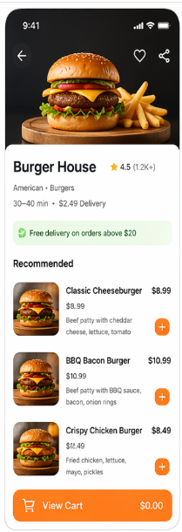

SCREEN:04
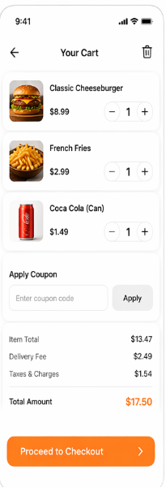
Familiar Elements:
- Item List with Quantity (+ / -)
  - Standard cart behavior
- Total Amount Section
  - Clearly shows billing
- “Proceed to Checkout” Button
  - Common CTA
- Coupon Input Field
  - Standard in e-commerce apps
Unfamiliar Elements:
- Swipe to Delete Item
  - Users may not know this gesture
- Auto-applied Coupons
  - Might confuse users if not clearly shown

